Fanny Bay Flyer February 2019

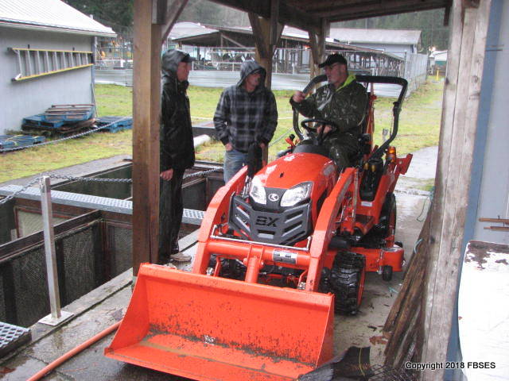
"Brenda" is FBSES' new tractor, seen in its carport. From left are Ross Radford, Randy Lousier and Frank Lines.

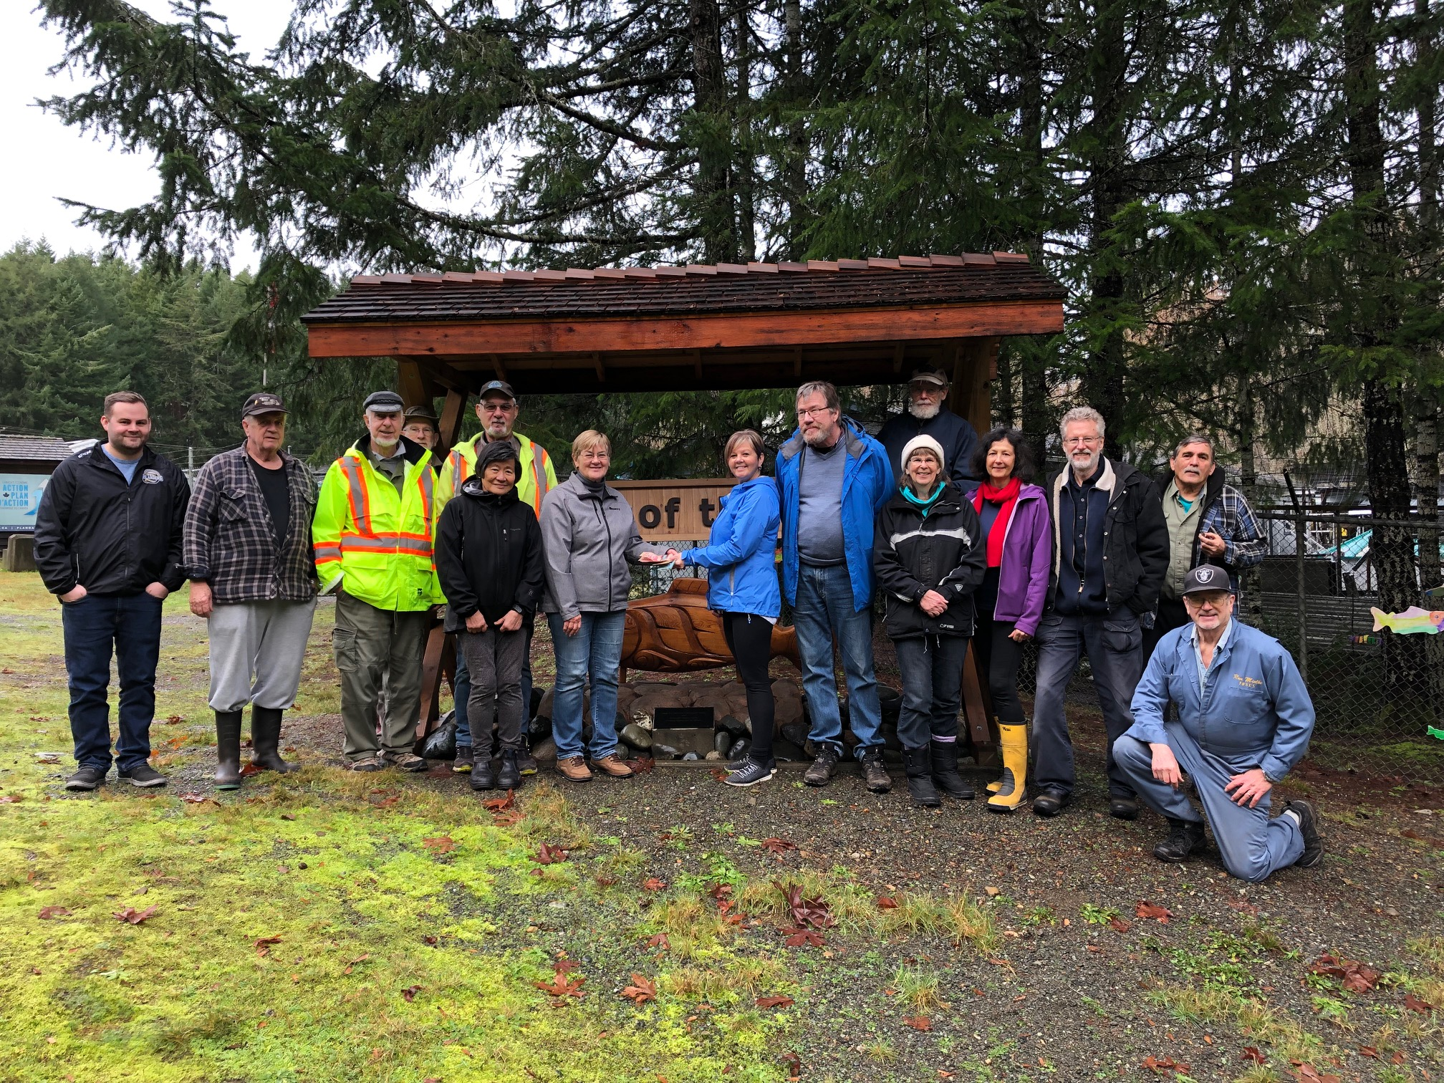
FBSES members greet Roxanne Milligan, center right, who presents a cheque for $1000 to president Judy Ackinclose.
The donation is from the Fanny Bay Inn's 50-50 Twoonie draw. In the picture, left to right, front row, Bessie Britt, Judy Ackinclose, Roxanne Milligan, Bill French, Janet Haigh, Lorrie Williamson, Jens Johansen, Larry McDonald, Ron Mielke. Back row, l to r, John Milligan, Finn Keim, Dick Walters, Dave Sands, Frank Lines and John Todd. Photo by Keith Thibault.

